Virtual Library System

**Group**: Midnight Kamikaze Pilots™  
**Members**: Josh Gaston, John Carroll, Chase Counsell, Ryon Campbell, Wan Lau

COMP 3700 Software Modeling and Design

Table of Contents

1. Domain Analysis
   1. Concept Statement
   2. Conceptual Domain Model (i.e., Class Domain Model)
   3. Domain State Model
2. Application Analysis
   1. Use Cases (at least 15 top level use cases)
   2. Application Interaction Model
      1. Essential Use Cases, Scenarios, and High-level SSD
      2. Concrete Use Cases and Detailed SSD
   3. Application Class Model
   4. Application State Model
3. Consolidated Class Model
4. Model Review

Domain Analysis

Concept Statement

The main library class holds the name of the library and keeps track of the customers, addresses, books, accounts, authors, and the reports, as well as the numbers for all of these items. The library also holds a reference to the librarian over the library. The librarian is able to add, delete, and modify all of the items inside of the library. The librarian can also renew books for customers and check in books for customers.

The library stores a list of customers that keeps track of the customer’s name, phone, and address. The address stores the street, city, state, and zip. Customers are associated with accounts that keep track of their personal reports. The account also has a unique id, the date of creation, a status indicating whether it is open, suspended, or closed, and other stats such as how many books are issued to the account, the number of late and lost books. The account is able to check out books as well as reserve books, pay fines, and view the personal status of the customer holding the account. The account holder can also create a reservation for a book that is currently checked out. At that point they will be placed in a reservation queue until the book is returned where the first to enter the queue will receive priority for checking out the book.

The reports store all the information of the transactions performed by the customers through their accounts. Each report has a unique id, a creation date, a due date, the status of the report and whether the book was checked in late or lost. This information is later used to compute the statistics for the account.

The books stored in the library are identified by their individual ISBN. They also store the title the number of pages, the genre, and a brief overview for the book. The library also holds a list of authors that describes the name of the author, his birth date, and a brief bio describing the author. The system also keeps tracks of reviews created by customers for both the books and the authors stored in the library, along with a list of favorite books for each customer.

Conceptual Domain Model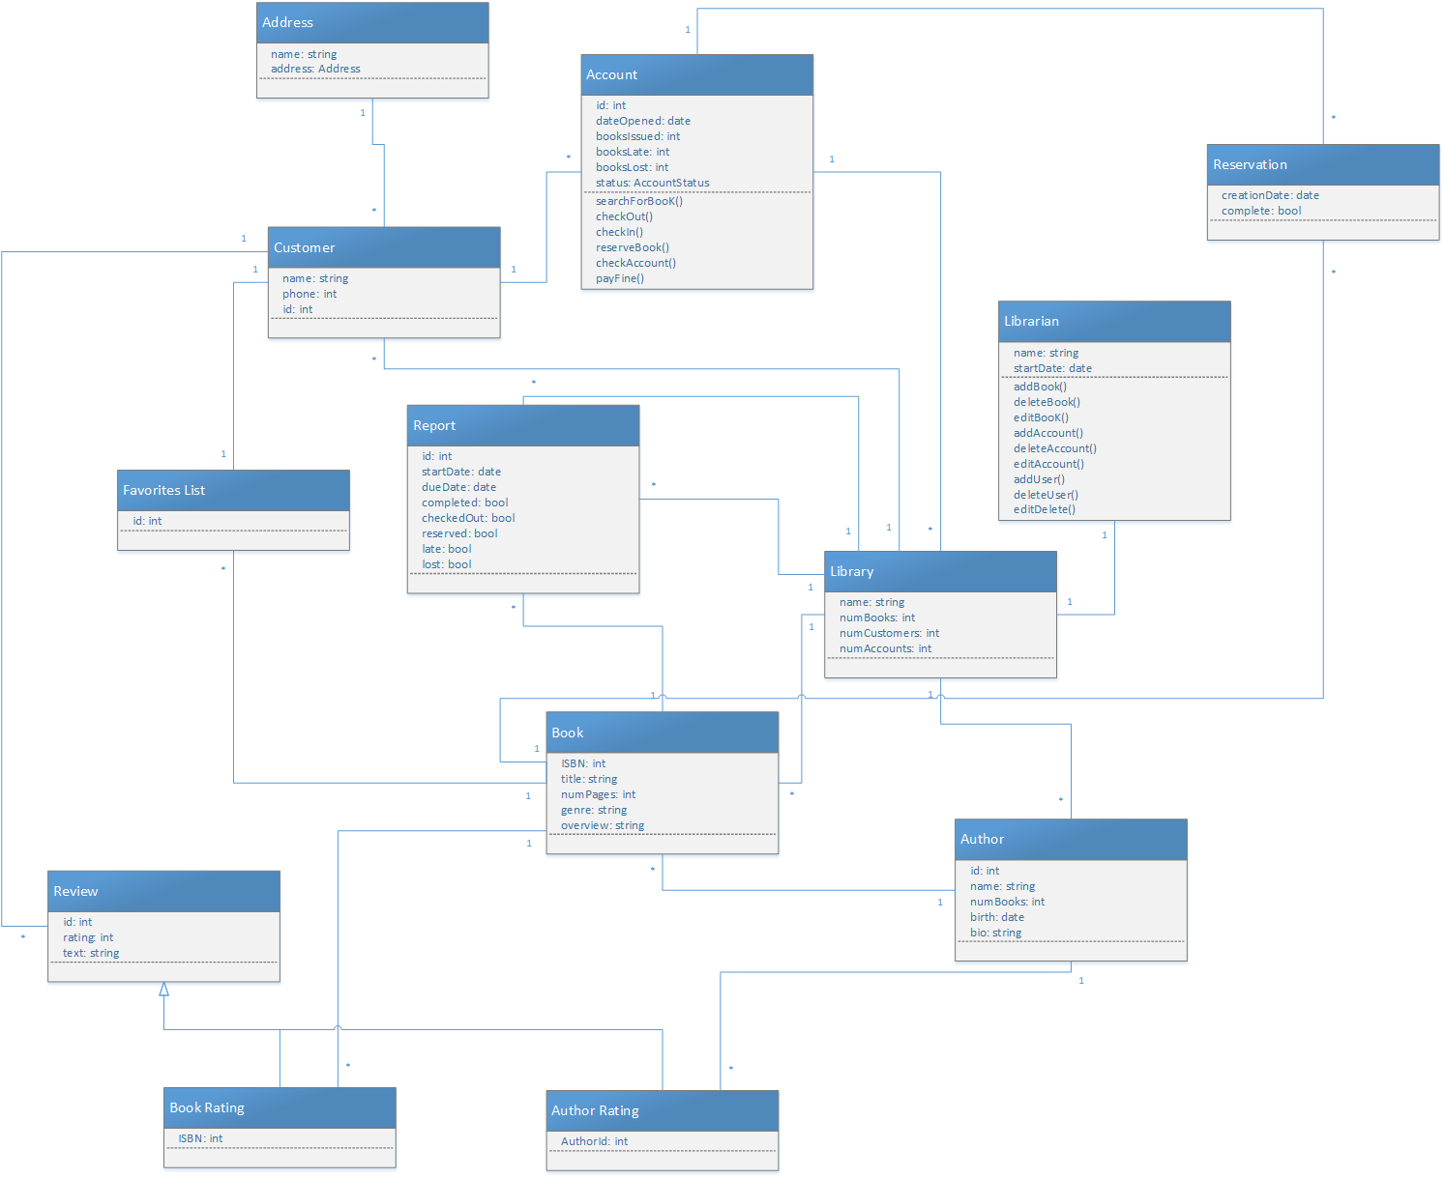

    Domain State Model

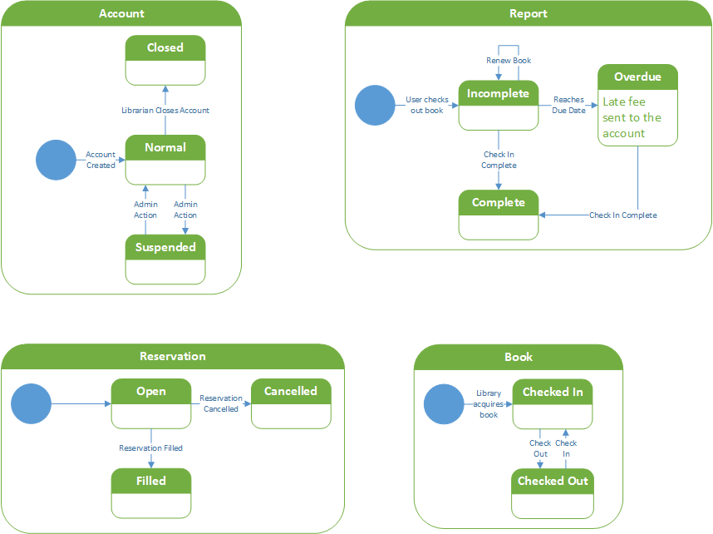

Application Analysis

Use Cases (Use Case Diagram)

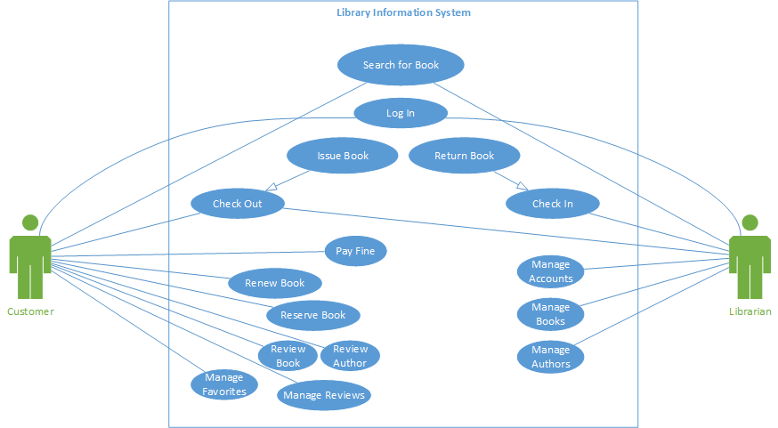

Application Interaction Model

Essential Use Cases

**Log In**: User enters id and password and the system verifies the pair and checks their access level  
**Check In**: The librarian sends a check in request  
**Check Out**: The customer sends a check out request  
**Search for Book**: Checks the system for the specified book.  
**Pay Fine**: User pays any outstanding fines that are associated to their account.  
**Renew Book**: Extends the due date for a checked out book.  
**Reserve Book**: Used to create a queue of customers to decide who gets the books once it is checked back in from the previous customer.  
**Review Book**: Gives the customer a chance to provide feedback through a rating and a text description.  
**Review Author**: Gives the customer a chance to provide feedback through a rating and a text description  
**Manage Favorites**: Allows the customer to add and remove books and authors from their favorites list.  
**Manage Reviews**: Allows the customer to remove and edit the reviews they have created for authors and books.  
**Issue Book**: The system evaluates the check out request  
**Return Book**: The system evaluates the check in request  
**Manage Accounts**: Allows the librarian to add, delete, and edit accounts for customers.

**Manage Books**: Allows the librarian to add, delete, and edit books.

**Manage Authors**: Allows the librarian to add, delete, and edit authors.  
**Issue Fine**: adds fine to an account that has not checked in a book before the due date has passed up.

Scenarios

Log In:

1. The customer opens up the Virtual Library Information.
2. The customer enters his user ID in the ID field
3. He then enters his password
4. He click the login button
5. Customer has successfully logged in

Check In:

1. The Librarian logs into the system
2. The librarian selects the check in option
3. The Librarian then scans in the book that he’s about to check in
4. The Librarian reviews the check in information
5. The Librarian has successfully checked in a book back into the system for review

Check Out:

1. The customer logs into the Virtual Library system
2. He finds the book he wants to check out
3. While viewing details of the book, he clicks the checkout button
4. The customer then receives a notification from the system informing him whether the book is available for checkout/ pickup.

Search for Book:

1. The user (either customer or Librarian) logs into the system
2. He clicks the search for book option
3. Inside, he enters the name of the book or name of author and clicks search
4. The system then returns the result of the search to the user

Pay Fine:

1. A customer logs into his account
2. He clicks into his account summary/ user info page
3. He sees that he has an outstanding fine on his page
4. He clicks the Pay Fine button on that page
5. The customer then has paid the fine on his account with his associated credit card

Renew Book:

1. The customer logs into the Virtual Library System
2. The Customer then goes and checkout his report page
3. He sees that he has an open report there
4. He clicks on the report of the checked out book
5. He then clicks the renew book button to send a book renewal request in

Reserve Book:

1. The customer logs into the Virtual Library system
2. He finds the book he wants to check out
3. While viewing details of the book, he clicks the checkout button
4. The customer then receives a notification from the system informing him the book has already been checked out/ or is in reserve
5. Then the system asks the customer if he wants to reserve the book instead
6. The customer selects yes and is then added to the list of people on reserve for that particular book

Review Book:

1. A customer logs into the Virtual Library System
2. He looks at his past checkout history in the profile page
3. In this list of past checkout history, he selects a book he has read before
4. Inside the book info page, he clicks the review book button
5. A book review form then appears
6. He slides the star slider of 1 to 10 to his choice of stars
7. Then underneath the slider, he writes about what he thinks of the book
8. Afterwards, he clicks the submit review button to submit the review

Review Author:

1. The customer logs into the Virtual Library system
2. He clicks the search for book option
3. Inside, he enters the name of an author in the author field and clicks search
4. The system then returns the result of the search to the user
5. The user then clicks on the author’s name and is brought to the author’s page
6. Inside the author’s page, he clicks the review author button to bring up a author review form
7. In the author review form, he slides the star rating slider to his liking for the author
8. and underneath the slider, he writes his thoughts on the author inside the text field
9. Afterwards, he clicks the submit review button
10. The customer has now successfully submitted an author review

Manage Favorites:

1. The customer logs into the Virtual Library system
2. He clicks on his profile page
3. Inside, clicks on his favorite tab
4. In the favorite page, he can add, edit, or delete his favorite books
5. The user then deletes a few books from his favorites
6. The user then adds a new book to his favorite
7. After he is done, he clicks the confirm changes button, and the changes now reflect in his new favorite page.

Manage Reviews:

1. The customer logs into the Virtual Library system
2. He clicks on his profile page
3. Inside, clicks on his reviews tab
4. In the review page, he see all the past reviews he has created
5. A new page then shows up where he can edit or delete his reviews
6. He looks at a past review he has done, right underneath, he sees the options to edit, or delete a review
7. He selects edit for a particular review
8. The review form pops up
9. He makes some changes to his review
10. He then clicks the confirm edit
11. The review is now edited and changed

Issue Book Fails(bad account):

1. A customer tries to check out a book
2. The system see the customer’s checkout request
3. The system then looks the customer’s current account standing( suspended or not)
4. The system sees that the account is actually suspended
5. The system then returns a message back to the user telling them the book cannot be issued because of their current account status

Issue Book Fails(no book left):

1. A customer tries to check out a book
2. The system see the customer’s checkout request
3. The system then looks the customer’s current account standing( suspended or not)
4. The system sees that the account is actually okay
5. The system then checks for the book’s availability
6. The system see that all instances of that book is currently checked out
7. The system then returns a message back to the user telling them the the book cannot be issued because they’re all checked out currently
8. And right after, it prompts the user if they want to be in the reserve queue for the book

Issue Book Success:

1. A customer tries to check out a book
2. The system see the customer’s checkout request
3. The system then looks the customer’s current account standing( suspended or not)
4. The system sees that the account is actually okay
5. The system then checks for the book’s availability
6. The system see that there are instances of that book available
7. The system then returns a message back to the user telling them they have successfully checkout a book, and can be picked up

Return Book:

1. The librarian is checking in a book
2. She scans in the book
3. The systems checks back in the book

Manage Accounts:

1. the librarian logs into the system
2. She then clicks on the manage account tab
3. Inside the manage account page, she can see all the accounts, and an option to search through the accounts
4. She clicks inside of a certain account that she wants to view
5. Inside, she decided to select edit to change certain information within the account
6. Afterwards, she selects confirm changes and closes out of the account page
7. Then, she decides she wants to add a new account
8. She clicks add account
9. She proceeds to fill out all the information needed
10. Then she selects create account and finalizes the account
11. Lastly, she wants to delete an account
12. She goes into view of the account she wants to delete
13. she selects delete account
14. She is prompted with a pop up confirmation for the deletion
15. She selects yes, and the account is deleted

Manage Books:

1. the librarian logs into the system
2. She then clicks on the manage books tab
3. Inside the manage book page, she can see all the books, and an option to search through the books
4. She clicks inside of a certain books that she wants to view
5. Inside, she decided to select edit to change certain information within the book
6. Afterwards, she selects confirm changes and closes out of the book page
7. Then, she decides she wants to add a new book
8. She clicks add book
9. She proceeds to fill out all the information needed
10. Then she selects create book and finalizes the book
11. Lastly, she wants to delete an book
12. She goes into view of the book she wants to delete
13. she selects delete book
14. She is prompted with a pop up confirmation for the deletion
15. She selects yes, and the book is deleted

Manage Authors:

1. the librarian logs into the system
2. She then clicks on the manage authors tab
3. Inside the manage author page, she can see all the author, and an option to search through the author
4. She clicks inside of a certain author that she wants to view
5. Inside, she decided to select edit to change certain information within the author
6. Afterwards, she selects confirm changes and closes out of the author page
7. Then, she decides she wants to add a new author
8. She clicks add author
9. She proceeds to fill out all the information needed
10. Then she selects create author and finalizes the author
11. Lastly, she wants to delete an author
12. She goes into view of the author she wants to delete
13. she selects delete author
14. She is prompted with a pop up confirmation for the deletion
15. She selects yes, and the author is deleted

Issue Fine:

1. The librarian is checking in a book
2. She scans in the book
3. The systems checks back in the book
4. But however, the system see that it is past the due date
5. So the system adds the appropriate amount of fine to the account that book was checking in from
6. The System also then suspends that account

High-Level System State Diagrams

**Log In**  
  
**Check In**



**Check Out**



**Search Book**  


**Pay Fine**



**Renew Book**



**Reserve Book**  


**Review Book**  


**Review Author**  


**Manage Favorites**  


**Manage Reviews**  


**Issue Book**  


**Return Book**  


**Manage Accounts**  


**Manage Books**  


**Manage Authors**  


**Issue Fine**  


Concrete Use Cases

**Log in**: customer enters customername and password into text field and clicks the confirmation button. The system verifies the credentials and pulls up the appropriate menu based on the account if they are valid.

**Check in**: the librarian scans or types the book’s ISBN into the text box on the check in menu. Then the librarian can click the confirmation button to confirm the check in request and close the report.

**Check out**:  the customer uses the search function to find the book’s info page in the database. If the book is checked in then the customer may click the checkout button to add the book to their cart. Whereupon the customer may go see their cart and click the confirmation button to confirm and complete their checkout.

**Search for Book**: from the menu the customer or librarian may enter a search term in the search text box and click the search button to send a search request to the system which will then search the database based on the instructions provided and return a page containing a list of the returned search results.

**Pay fine**: the customer can navigate to their account summary page from the customer menu whereby the customer may then view their outstanding fines and if there are any they can click the pay button to send a charge to the credit card associated with their account.

**Renew book**: from the customer menu the customer can navigate to their report page to where they can view any open reports (reports where the book has not been returned and the due date has not been reached). The customer can then hit the renew button to send a request to the system for the librarian to either accept or deny.

**Reserve book**: if a book is currently checked out the customer can click the reserve button to send a reserve request to the system whereby the system will put the customer into the reservation queue.

**Review book**: On a book info page a customer may click on the review button to bring up a book review form. The customer can select the rating on a slider from 1 to 10 and write a review in the text box below. The customer can click the confirmation button to send the review to the system to update the book statistics accordingly.  
**Review Author**: On an author info page a customer may click on the review button to bring up an author review form. The customer can select the rating on a slider from 1 to 10 and write a review in the text box below. The customer can click the confirmation button to send the review to the system to update the author statistics accordingly.

**Manage Favorites**: On the customer menu the customer can select the manage favorites tab to access the favorites menu. The customer can then choose to add or remove books or authors from their respective favorites list.  
**Manage Reviews**: On the customer menu the customer can select the manage reviews tab to access the reviewsmenu. The customer can then choose to add, edit, or delete their own reviews.

**Issue Book**: The system evaluates the customer’s check in request by determining if their account state is suspended or not. If the account is in good standing then the system accepts the request.(The customer is then able to pick up the book from the librarian.)  
**Return Book**: The system evaluates the librarians check in request and adds any fines to the account if necessary.

**Manage Accounts**: On the librarian menu the librarian can select the manage accounts tab to access the accounts menu. The librarian can then choose to add, edit, delete, or view accounts in the system. (View is used for librarians to issue books to customers.)  
**Manage Books**: On the librarian menu the librarian can select the manage books tab to access the books menu. The librarian can then choose to add, edit, delete, or view books in the system.  
**Manage Authors**: On the librarian menu the librarian can select the manage authors tab to access the authors menu. The librarian can then choose to add, edit, delete, or view authors in the system.

**Issue Fine**: In evaluating the check in request if the system notices that the due date has expired then it will issue the appropriate fine to the account of the customer and suspend it until the fine is paid.

Detailed System State Diagram

**Log In**

**Check In**

**Check Out**

**Search for Book**

**Pay Fine**

**Renew Book**

**Reserve Book**

**Review Book**

**Review Author**

**Manage Favorites**

**Manage Reviews**

**Issue Book**

**Return Book**

**Manage Accounts**



**Manage Books**



**Manage Authors**

**Issue Fine**

Application Class Model



Application State Model

Request Entity Application State Model









































  
continues on next page





Consolidated Class Model



Model Review

When modeling any system, it is very important to judge the resulting model’s correctness, completeness, and consistency. We considered these when creating and judging our models.

For correctness, the model for our system performs well. Our boundary and entity objects all have descriptive nouns for names. Our use cases all have descriptive verbs for names. The descriptions fit well with our concept statement.

We worked on checking the completeness of our model by checking the attributes and events in each of our objects to make sure it was correct. We used linguistic analysis on both our use cases and concept statement to gather all potential classes and associations in the application domain.

We were constantly checking the consistency of our model. There aren’t any classes or cases with the same names. When choosing names we made sure that similar names will have a similar concept. We also simplified some classes that have the same attributes by placing them in a generalization relationship.